ASSIGMENT #5 PF

QUESTION #8

CODE:

#include<iostream>

using namespace std;

int main()

{

int arraymn[2][2] = { {1,2},{3,4} };

cout << "Original matrix is : " << endl;

for (int i = 0; i <2; i++)

{

for (int j = 0; j < 2; j++)

{

cout << arraymn[i][j] << " ";

}

cout << endl;

}

cout << "Matrix after taking transpose is : " << endl;

for (int i = 0; i <2; i++)

{

for (int j = 0; j < 2; j++)

{

cout << arraymn[j][i] << " ";

}

cout << endl;

}

system("pause");

}

Output

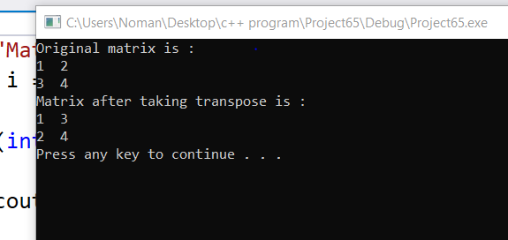

Question #6

Code

#include<iostream>

using namespace std;

int main()

{

int a = 9; int k, x = 0;

int array1[10];

int array2[10];

cout << "PLZ Enter first array : ";

for (int i = 0; i < 10; i++)

{

cin >> array1[i];

}

cout << endl;

cout << "second array is :";

for (int i = 0; i < 10; i++)

{

cin >> array2[i];

}

for (int k = 0; k < 10; k++)

{

if (array1[k] == array2[a])

{

x++;

a--;

}

if (x == 10)

{

cout << "array is reversed !!\n";

}

else

{

cout << "array is not reversed !!\n";

}

}

system("pause");

}

OUTPUT

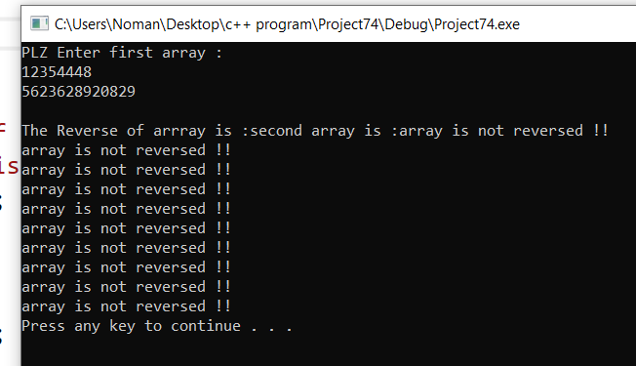

QUESTION #9

#include<iostream>

using namespace std;

int main()

{

int array1[2][2] = { { 2,2 },{ 2,2 } };

int array2[2][2] = { { 2,2 },{ 2,2 } };

int array3[2][1];

cout << "Matrix NO One : " << endl;

for (int i = 0; i < 2; i++)

{

for (int j = 0; j < 2; j++)

{

cout << array1[i][j] << " ";

}

cout << endl;

}

cout << "Matrix NO Two : " << endl;

for (int i = 0; i < 2; i++)

{

for (int j = 0; j < 2; j++)

{

cout << array2[i][j] << " ";

}

cout << endl;

}

for (int i = 0; i < 2; i++)

{

int sum = 0;

for (int j = 0; j < 2; j++)

{

sum = sum + array1[i][j] \* array2[i][j];

}

for (int i = 0; i < 2; i++)

{

for (int k = 0; k < 1; k++)

{

array3[i][k] = sum;

}

}

}

cout << "Product of given matrix is : " << endl;

for (int i = 0; i < 2; i++)

{

for (int j = 0; j < 1; j++)

{

cout << array3[i][j] << " ";

}

cout << endl;

}

system("pause");

return 0;

}

Output

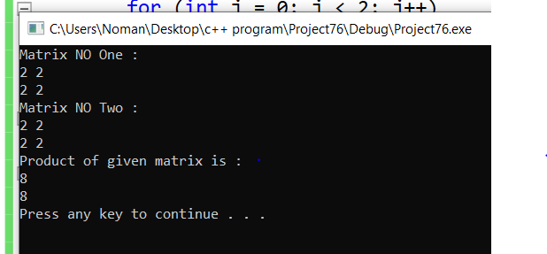

QUESTION #2

#include<iostream>

using namespace std;

int main()

{

int x = 0;

int y = 0;

int z = 0;

int a = 0, b = 0, c = 0;

int arr[6], arr1[6];

cout << "Enter data:";

for (int i = 0; i < 6; i++)

{

cin >> arr[i];

}

for (int i = 0; i < 4; i++)

{

y = arr[i];

z = arr[i + 2];

x = y \* z;

cout << x << " ";

}

for (int i = 4; i < 6; i++)

{

a = arr[i];

b = arr[i - 4];

c = a \* b;

cout << c << " ";

}

system("pause");

}

OUTPUT

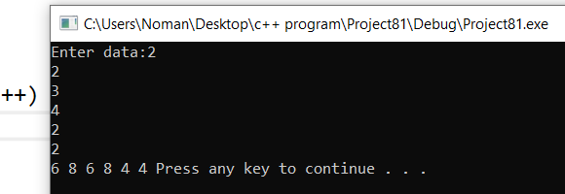

Question #7

#include<iostream>

using namespace std;

int main()

{

int largestColumn, largestrow;

int array[3][3];

cout << "Enter an array of 3x3 : " << endl;

for (int i = 0; i < 3; i++)

{

for (int j = 0; j < 3; j++)

{

cin >> array[i][j];

}

cout << endl;

}

int column;

int row;

cout << "\nEnter Number of column : ";

cin >> column;

cout << "\nEnter number of row : ";

cin >> row;

//---------for columns------------

for (int k = 0; k < 3; k++)

{

largestColumn = array[k][column - 1];

for (int l = 1; l < 3; l++) {

if (array[l][column - 1] > largestColumn)

{

largestColumn = array[l][column - 1];

}

}

}

//----------for Row------------

for (int i = 0; i < 3; i++)

{

largestrow = array[row - 1][0];

for (int j = 1; j < 3; j++)

{

if (array[row - 1][j] > largestrow)

{

largestrow = array[row - 1][j];

}

}

}

cout << "\nLargest element in your given column is : " << largestColumn << endl;

cout << "\nLargest element in your given row is : " << largestrow << endl;

system("pause");

}

OUTPUT

